Verilog-A model of LPF :
RC=feed_res*feed_cap;
den_arr[0]=1;
den_arr[1]=RC;
num_arr[0]=feed_res;

V(Voutm_STG1) <+ laplace_nd(I(I_in_m),num_arr, den_arr) ;
V(Voutp_STG1) <+ laplace_nd(I(I_in_p),num_arr, den_arr) ;

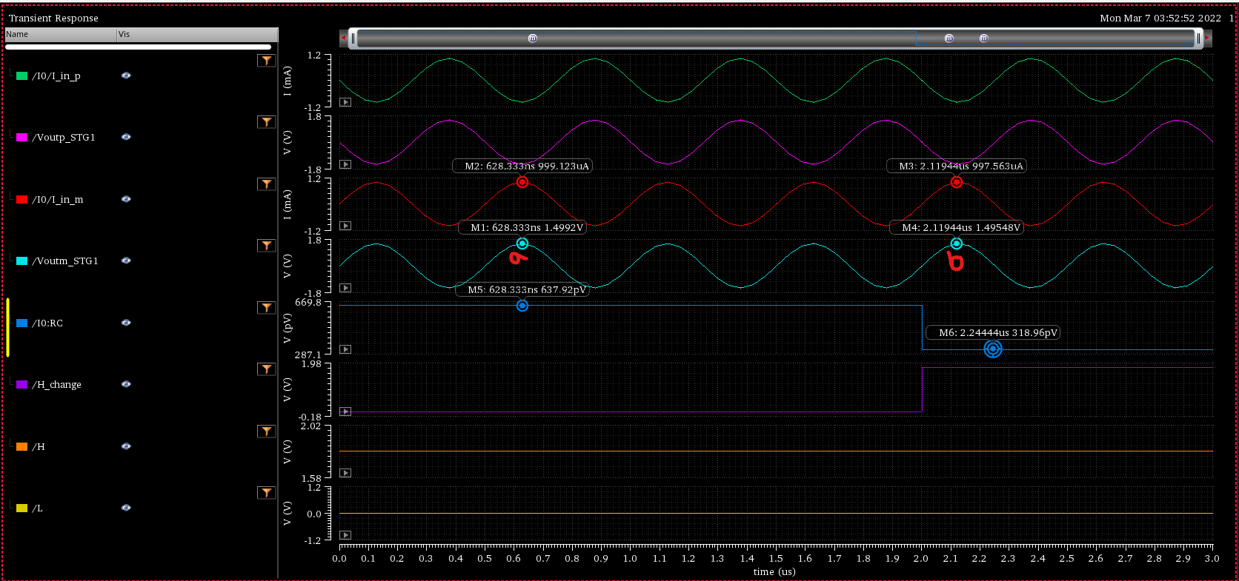
Here at point a, the gain of the filter is 1.5K while RC=637.92p And at point b, gain=1.5K while RC=318.96p. The change of the filter behavior is not reflecting according to R and C value. It is only giving the correct filter behavior for the R and C value at time=0.

