Area: Analog Mixed Signal
Specific Area: VHDL view and symbol creation
Error Message: xmvhdl_p: *F,NOLSTD: logical library name STD must be mapped to a design library
Description: I am doing AMS verification for a RX Path. A vhdl code is already present for rx_resampler block. To perform the AMS test, a view and a symbol of rx_resampler block is required. I have used two options to create the view.
- Library ManagerFileNewcellview
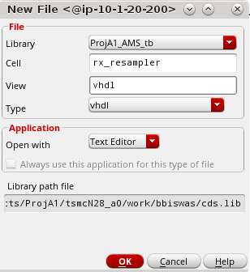
Getting error at the time of extract (FileExtract)

Error file:
- Library ManagerFileNewcellview
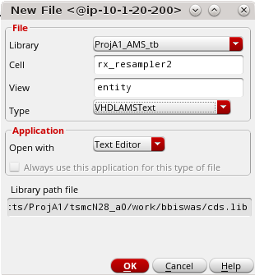

Error file:

