3. HDI PCB

3.1 HDI Type

The following figure illustrates the various HDI/Microvia Types.
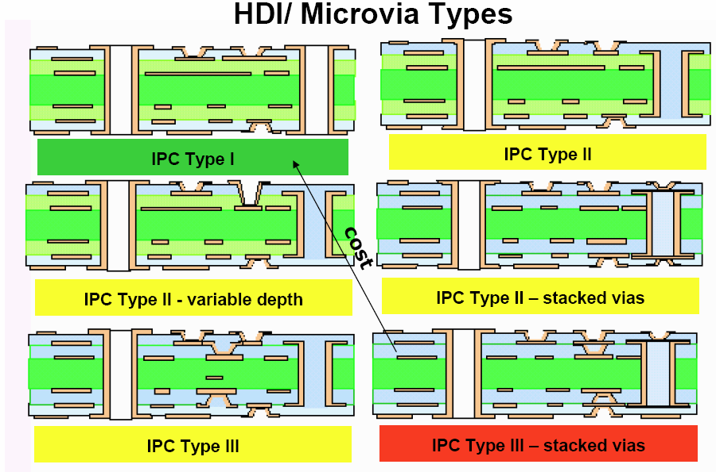

The Woodstock project plans to use IPC Type I design firstly, if the IPC Type I design can not fan out the BGA signals, then the IPC Type II will be next approach. If the IPC Type II can not fan out the BGA signals, the IPC Type II – stacked vias will be the last approach. Need PCB Fab to fill up the following table.
# | HDI/Microvia Type | PCB Fab Response
# | HDI/Microvia Type | Doable (Yes/No) | Estimated cost/per inch
A | IPC Type I | YES | 6 layer
A | IPC Type I | YES | 8 layer
B | IPC Type II | YES | 6 layer
B | IPC Type II | YES | 8 layer
C | IPC Type II – Stack vias | YES | 6 layer
C | IPC Type II – Stack vias | YES | 8 layer

3.2 HDI PCB Stack-up
The following figure illustrates the recommended PCB stack-up dimensions and materials. Need PCB fabricator feedback whether they can support this PCB stack up or not.
Note: The thickness of the PCB doesn’t have to 1.0mm. If possilbe, please PCB fab provide the PCB’s thickness value base on their best economical solution.

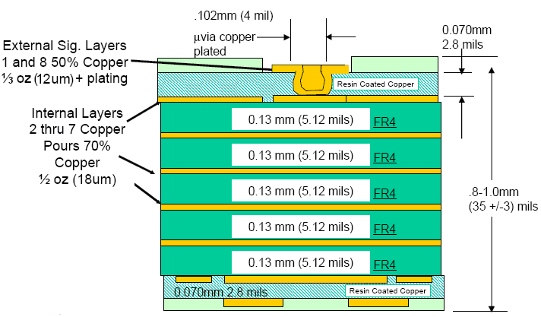

# | PCB Fab Response (Comment)
A | Stack up: 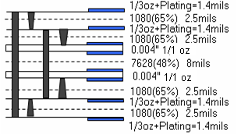
B | Thickness: 1.0mm
C | Others:

3.3 HDI PCB Layer
The Woodstock PCB board may be 8 layers or 6 layers board.
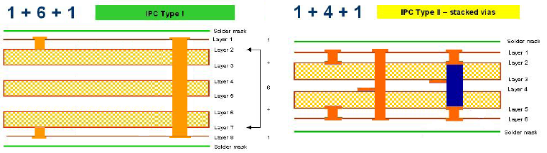

This type can not be built and the PYPE II –stacked vias should be as following picture.

4. HDI Via
The following figure illustrates the Microvia (Blind/Buried via) and through hole dimensions and materials.
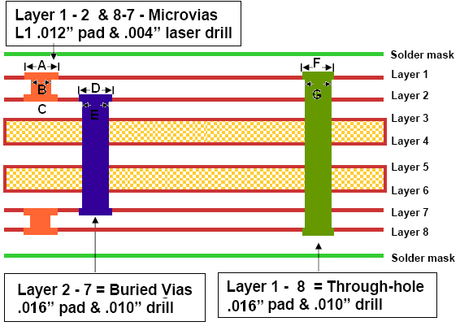

Need PCB fabcritor to fill up the following table.
# | Description | um | mil | PCB Fab Response
A | Layer 1 pad for layer 1 to 2 Microvia | 300um | 10mi
B | Laser drill diameter for Microvia | 100um | 4mil
C | Layer 2 pad for layer 2 to 1 Microvia | 300um | 10mil
D | Pad for buried via | 300um | 16mil
E | Conventional drill diameter for buried via | 250um | 10mil
F | Pad for Though hole | 300um | 16mil
G | Conventional Drill diameter for Through hole | 250um | 10mil
Note: The pad dimension is the sum of the diameter of the drill hole and the clearance zone for drill hole.

5. Land Pad
The following figure illustrates the None-solder Mask defined (NSMD) and Solder Mask defined (SMD) BGA ball land pattern. NSMD configuration is preferred due to its tighter control on copper etch process and a reduction in the stress concentration points on the PCB side compared to SMD configuration. The Woodstock project requires using NSMD configuration.
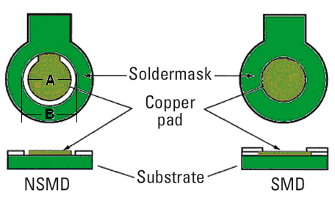

Need PCB fabcritor to fill up the following table.
# | Description | Design | Finished | PCB Fab Response
A | Copper Pad | 10mil | 10mil | 10+/-15%
B | Solder Mask Opening | 12mil | 12mil | 12+0-15%
C | Definition of Solder Mask | 1mil | 1mil | 2 mils

The following figure indicates the clearance of BGA pad is closed to Microvia one, ( 0.0139” x2 – 0.0065” – 0.0065” – 0.012”) / 2 = 0.0014”) To cover this issue, the via pad need be covered by plaint
