Various Types of Transaction-based Interfaces (TLM) for DisplayPort VIP
Introduction
Different RTL designs often require different specially designed parallel interfaces. These different interface requirements serve varying needs, such as certain block not ready when design under development, to speed up simulation during unit testing, DisplayPort need to connect to other protocols. Instead of creating a new physical pin interface, this blog introduces a Transaction-Based Customer Interface, which is compatible with all user’s specific parallel interface requirements. Traditional way of creating a new physical pin interface is time consuming. Even a slight difference in the interface definition requires the development of a full pin interface as the pin interface is 1 to 1 solution. Also, multiple physical interfaces are also confused to user. This interface allows the user to use the VIP transactions and callback instead of predefined physical pins. For example, customers request 32bit aligned interface and CIO mode interface. With traditional methods, VIP needs to create 2 different parallel interfaces. With the Transaction-Based Customer Interface, VIP only uses one interface to fulfill two different customer’s requirements.
Solution
To address the above issue, we are proposing the Transaction-Based Customized Interface is a configurable interface compatible with all user’s specific parallel interface requirements. This interface allows the user to use the VIP transactions and callback instead of predefined physical pins. Instead of using the signals on physical pins, the DisplayPort VIP provides callbacks and transactions. User can use callbacks and transactions to access the data and modify a transaction inside of VIP. This provides flexibility to user.
Below is the test topology of Source VIP connecting to Sink DUT without the pin interface.
Figure 1 is the flow with Source as VIP and Sink as DUT. In this scenario, Source VIP provides data in the form of transaction of pre-defined fields through callback. The predefined fields data masks or bundle to form customer defined pin interface in testbench. Special sideband signals are extracted from transaction fields also. DUT detects the data, control signals through defined pin interface.

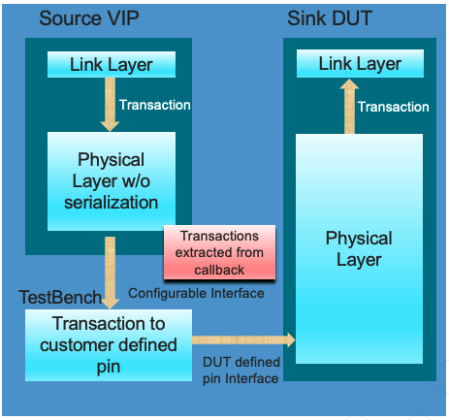

Figure 1: Source VIP connects to Sink DUT with The Transaction-Based Customized Interface
Example
Interface#1 – 32-bit Parallel Interface
In 128b/132b channel coding, customer request 32bit parallel interface instead of transmitting/receiving 1 bit at a time in order to fasten simulation time without serialization block. From the spec, each block has 132bit (FEC disabled) or 129bit (FEC enabled). This nature block is not aligned with 32bit requirement. Blocks need to break to 32bits. In the traditional way, VIP need to create new physical interface, serialize the block first and reform it to aligned as 32bit symbols. In the proposed way, VIP provides the transaction and TB align it to 32bits symbol and no need to create physical interface. Below is the figure to illustrate that VIP is able to provide 32bit data from Transaction based interface.
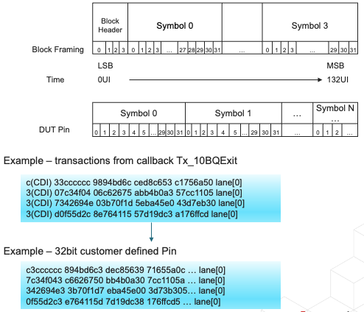

Figure 2: Customized 32bits parallel interface
Interface#2 -
Another interface is designed with Transaction-Based interface. Testbench is able to extraction from transactions and fields to generate data and control signals as they request.
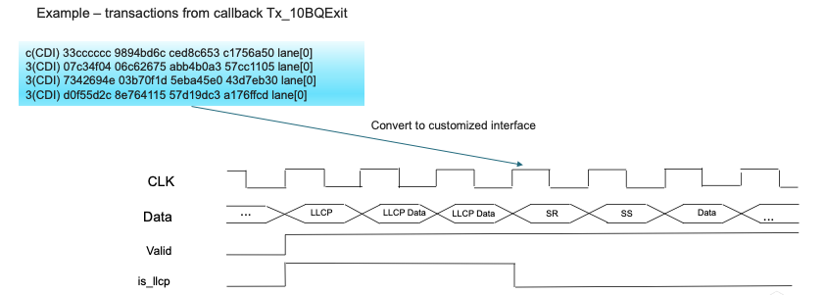
Figure 3: Customized CIO interface
Conclusion
The DisplayPort VIP Transaction-Based interface supports both 128b/132b channel coding and 8b/10b channel coding, with different feature, such as ALPM(Advanced Link Power Management), FEC(Forward Error Correction). User can verify their RTL designs with difference interfaces using Transaction-Based interface. In 128b/132b channel coding, user can configure to symbol based 32bits interface, or super symbol based 132bit etc. In 8b/10b channel coding, user can configure to include or not include skew, FEC ect. User can also configure to switch between 8b/10b channel and 128b/132bit channel.
This Transaction-Based customer interface can support all customer’s specific parallel interface. The interface is compatible with all customer’s specific parallel interface to fasten the integration and simulation time.

More Information:
Cadence has a very mature Verification IP solution. Verification over many different configurations can be used with DisplayPort 2.1 and DisplayPort 1.4 designs, so you can choose the best version for your specific needs. The DisplayPort VIP provides a full-stack solution for Sink and Source devices with a comprehensive coverage model, protocol checkers and an extensive test suite.
More details are available in DisplayPort Verification IP product page, Simulation VIP pages
If you have any queries, feel free to contact us at talk_to_vip_expert@cadence.com

