Unlocking Efficient Debugging with Verisium WaveMiner

Overview of WaveMiner
WaveMiner is part of the Verisium suite of AI-driven verification tools that automate the root cause analysis of misbehavior introduced between two versions of the same RTL design. By analyzing passing and failing waveforms, WaveMiner ranks and highlights the signals and timepoints relevant to the misbehavior, simplifying the regression debug process.
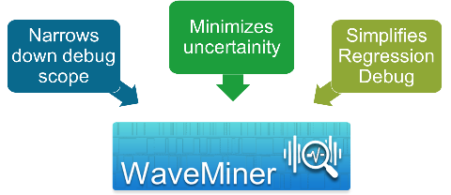

Why Do We Need WaveMiner?
- Narrows down debug scope by ranking culprit signals
- Minimizes uncertainty by engaging stakeholders quickly
- Reduces regression debug effort and maximizes verification throughput
- Helps to dismiss unlikely root causes and identify design changes causing failures

WaveMiner Inputs and Outputs
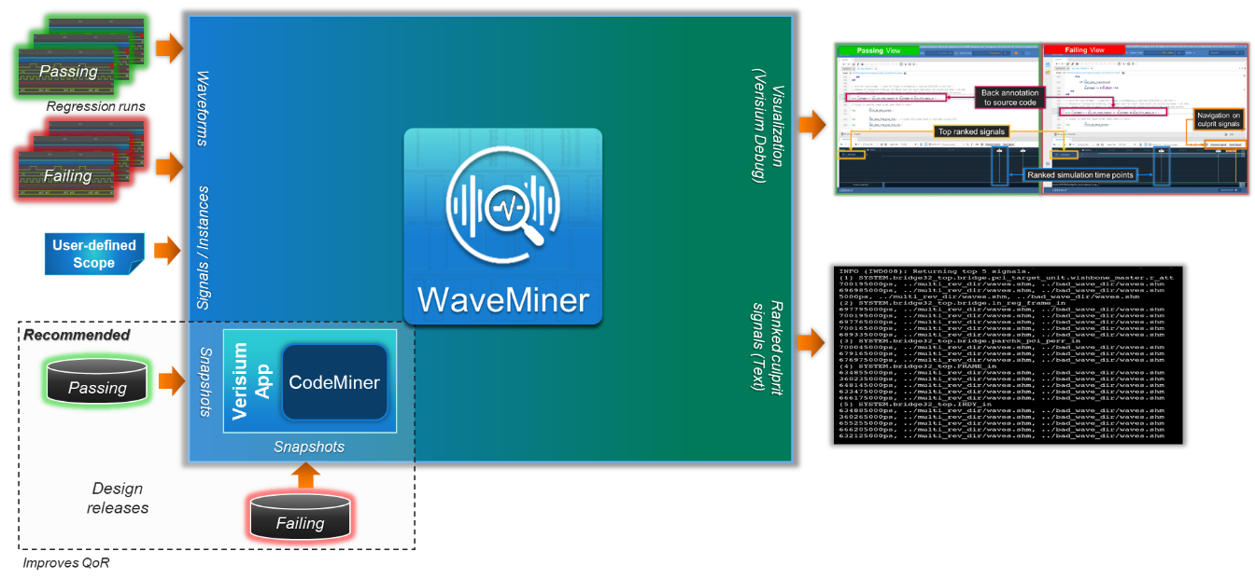

Inputs
- One or more passing waveforms and one or more failing waveforms
- Generated with two different versions of the same design
- Analysis scope: Two snapshots or user-defined list of signals/instances

Outputs
- Text report with ranked culprit signals and simulation time points
- Visualization in Verisium Debug
- Interactive navigation through ranked signals and timepoints

WaveMiner Flow
WaveMiner performs signature mining on passing and failing waveforms, cross-validates the results, and ranks the design signals and simulation timepoints according to their contribution to the misbehavior. The results are visualized in Verisium Debug for detailed analysis.
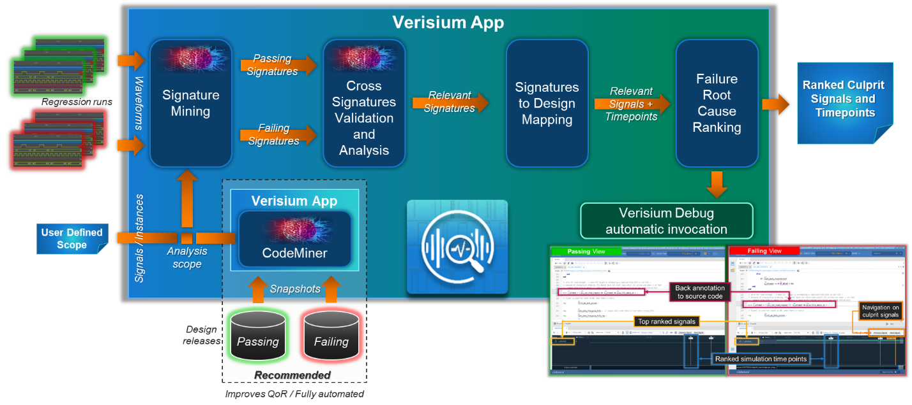

WaveMiner Functionality
- Signature mining from multiple passing and failing waveforms
- Ranking of failure root cause candidate signals and timepoints
- Automatic invocation of Verisium Debug for detailed analysis
- Minimizes debug effort and improves quality of results (QoR)

WaveMiner Dual Waveform GUI View
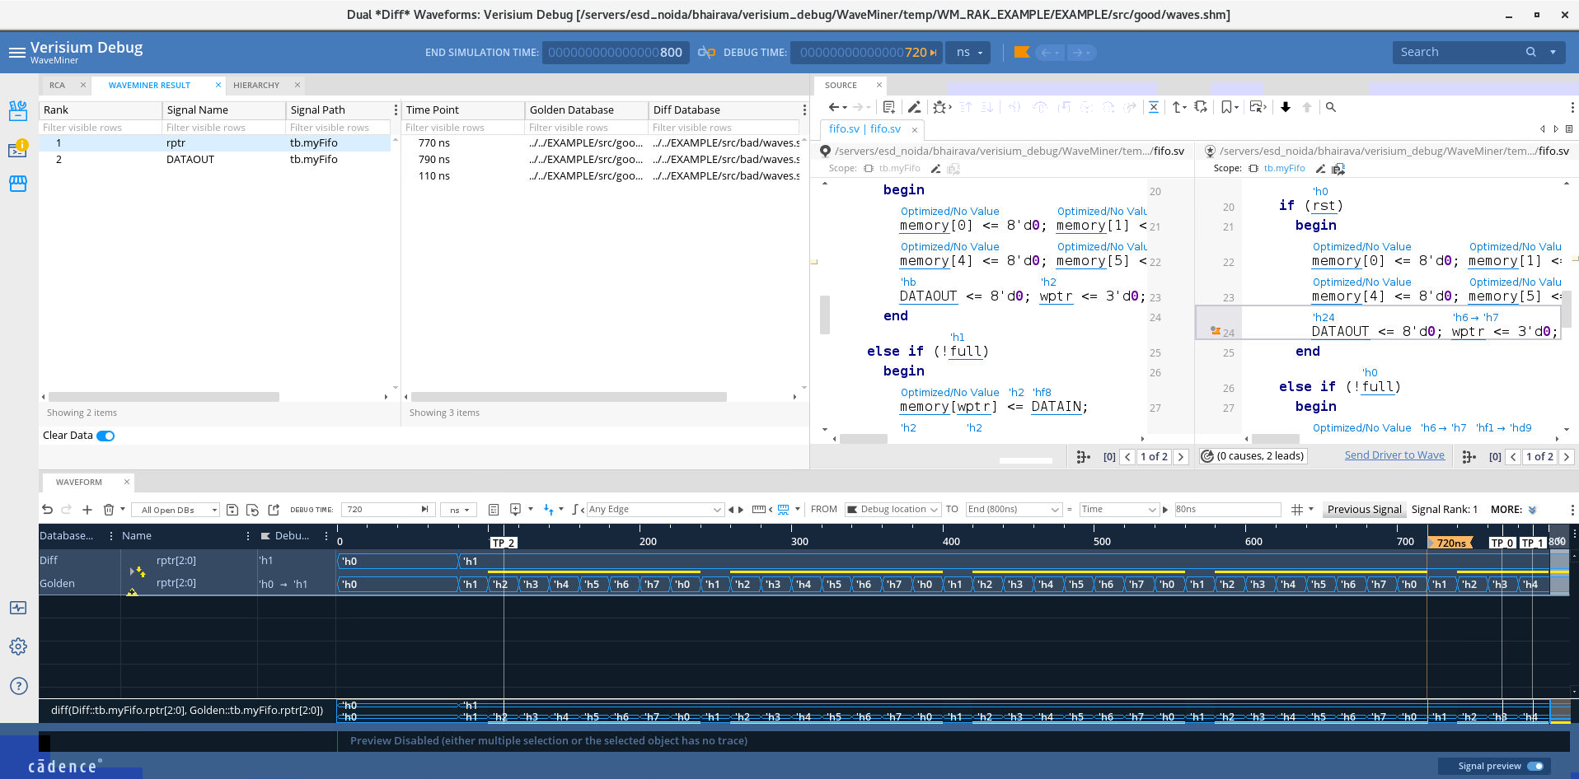

WaveMiner Setup

Environment Setup
- Set environment variables for Verisium Apps and Verisium Debug
- Install required licenses for waveform analysis

Running WaveMiner
- Use the provided commands and scripts to run WaveMiner
- Generate ranked list of signals and timepoints for debugging

Additional Resources
Below listed training bytes channel and a RAK from Cadence ASK will help you navigate through the complete WaveMiner flow and features.
Introduction_to_WaveMiner (Video)
Introduction to Verisium WaveMiner (RAK)

Summary
WaveMiner is a tool in the Verisium suite that automates the regression debug process. It performs signature mining on passing and failing waveforms, ranks design signals and simulation timepoints based on their contribution to misbehavior, and visualizes the results in Verisium Debug. By minimizing debug effort and improving the quality of results, WaveMiner is essential for designers and verification engineers.
This comprehensive guide captures the key points and functionalities of WaveMiner to aid users in leveraging its full potential.

