**Knowledge Booster Training Bytes – Virtuoso APPLICATION READINESS CHECKER (ARC)**

Most design teams use the schematic-driven connectivity-aware environment of Layout XL. However, due to the reuse of legacy designs, third-party tools, and the flexibility of the Virtuoso platform, a design can lose binding and connectivity.

Despite the layout being LVS clean, this loss of Layout XL compliance can result in incomplete or incorrect information in the design that can impact the layout process within Virtuoso.

This blog highlights the functionality developed and enhanced in the IC23.1 release to facilitate a more user-friendly layout flow within Virtuoso. Each application requires a different level of compliance (XL compliance, Innovus compliance, and so on) and has a dedicated interface to check this compliance. ARC provides a single-user interface for all applications. It is available by default in the XL, EXL, MXL tiers.

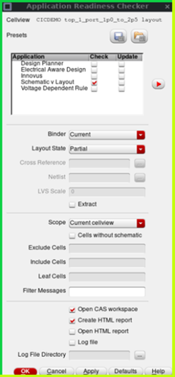

Each application has its own set of requirements regarding schematic correspondence and connectivity. All applications in the XL environment rely on the correspondence between the schematic and the layout, so these checks are shared. The XL-specific checks like Check Against Source (CAS), Update Binding, and Update Components and Nets (UCN) are consolidated under the “Schematic v Layout” application. Other applications like “Design Planner”, “Electrical Aware Design”, “Voltage-Dependent Rule”, and very recently, “Innovus” are available.

* The interface is application-driven, so the designers know what to run.
* The checks generate markers, which are available in the Annotation Browser.
* Custom checks and updates can be included (using SKILL).
* There are options to run on the entire library, exclude, include, define leaf cells, and filter messages.
* There are multiple reporting options: log file or HTML file, including a report per application and a summary.
* The HTML report generated to see the detailed status of each cellview.

All the related videos are linked together in a channel so that you can easily access and watch as many as you like.

~~[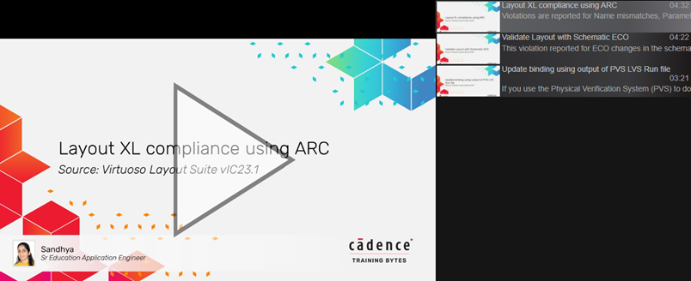](https://support.cadence.com/apex/ArticleAttachmentPortal?id=a1O3w000009mE80EAE&pageName=ArticleContent)~~

**Do You Have Access to the Cadence Support Portal?**

If not, follow the steps below to create your account:

* *On the*[*Cadence Support*](https://registration.cadence.com/CadenceApplicationLoginScreen?appcode=cos&langcode=en)*portal, select Register Now and provide the requested information on the Registration page.*
* *You will need an email address and host ID in order to sign up.*
* *If you need help with registration, contact*[*support@cadence.com*](mailto:support@cadence.com)*.*

To stay up-to-date with the latest news and information about Cadence training and webinars, [subscribe](https://www5.cadence.com/ES_LP.html)to the Cadence Training emails.

If you have questions about courses, schedules, online, public, or live onsite training, reach out to us at [Cadence Training](https://www.cadence.com/en_US/home/training/contact.html).

**Become Cadence Certified**

Cadence Training Services now offers digital badges for this training course. These badges indicate proficiency in a certain technology or skill and give you a way to validate your expertise to managers and potential employers. You can highlight your expertise by adding these digital badges to your email signature or any social media platform, such as Facebook or LinkedIn. To become [Cadence Certified](https://www.cadence.com/en_US/home/training/become-cadence-certified.html), you can find additional information [here](https://community.cadence.com/cadence_blogs_8/b/breakfast-bytes/posts/tranining2020). Go straight to the course exam at the [Learning and Support Portal](https://support.cadence.com/apex/CosLms_DoceboPage?deeplink=/pages/24/digital-badge-exams).

[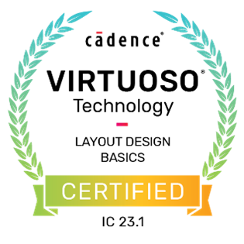](https://www.cadence.com/en_US/home/training/all-courses/84460.html)[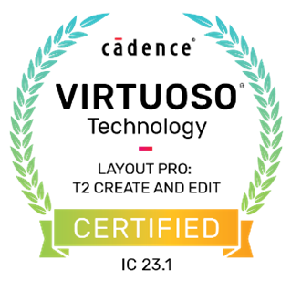](https://www.cadence.com/en_US/home/training/all-courses/85088.html)[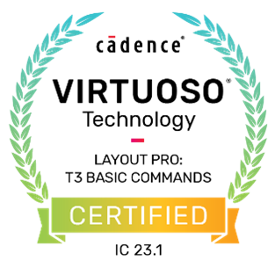](https://www.cadence.com/en_US/home/training/all-courses/85089.html)[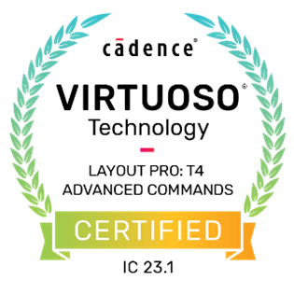](https://www.cadence.com/en_US/home/training/all-courses/85090.html)

**Related Resources**

| **Training Bytes (Videos)** | [Application Readiness checker](https://support.cadence.com/apex/ArticleAttachmentPortal?id=a1O3w000009mE80EAE&pageName=ArticleContent) |
| --- | --- |
| **Rapid Adoption Kits** | [Application Readiness Checker (ARC)](https://support.cadence.com/apex/articleattachmentportal?id=a1O3w000009lVrkEAE&pageName=ArticleContent&attachId=0693w00000Is0QpAAJ&sq=null&caseSessionKey=null) |
| **Online Courses** | [Virtuoso Layout Design Basics](https://www.cadence.com/en_US/home/training/all-courses/84460.html)  [Virtuoso Layout Pro: T2 Create and Edit Commands](https://www.cadence.com/en_US/home/training/all-courses/85088.html)  [Virtuoso Layout Pro: T3 Basic Commands](https://www.cadence.com/en_US/home/training/all-courses/85089.html)  [Virtuoso Layout Pro: T4 Advanced Commands](https://www.cadence.com/en_US/home/training/all-courses/85090.html) |

**About Knowledge Booster Training Bytes**

*Knowledge Booster Training Bytes* is an online journal that relays information about Cadence Training videos, online courses, and upcoming webinars that are available in the Learning section of the Cadence Learning and Support portal. This blog category brings you direct links to these videos, courses, and other related material, on a regular basis.

**Sandhya P S**

***On behalf of the Cadence Training team***

