

**Knowledge Booster Training Bytes – Virtuoso Layout Suite Photonics Designers**

Silicon Photonics has the potential to revolutionize many industries. Photonics, the science and technology of generating, controlling, and detecting light, has moved into mainstream electronic designs. This is particularly true for communications hardware, where bandwidth demands are so great that only photonic ICs (PICs) offer a viable solution. Other key application areas include data centers, antenna and RF systems, bio-photonics, and environmental sensing systems.

This Blog covers the Virtuoso Layout Suite EXL flow, focusing on features and aspects important to the photonics designers. In this you will learn how to use the Virtuoso Layout environment, emphasizing its usage for photonics. Also shown briefly is the integration with the INTERCONNECT optical simulator of Lumerical to highlight the ability of the solution to cover layout accurate simulation.Photonics is not a specific application but rather a mode for the framework. The user specifies at the start of the session that the framework will start in photonics mode.

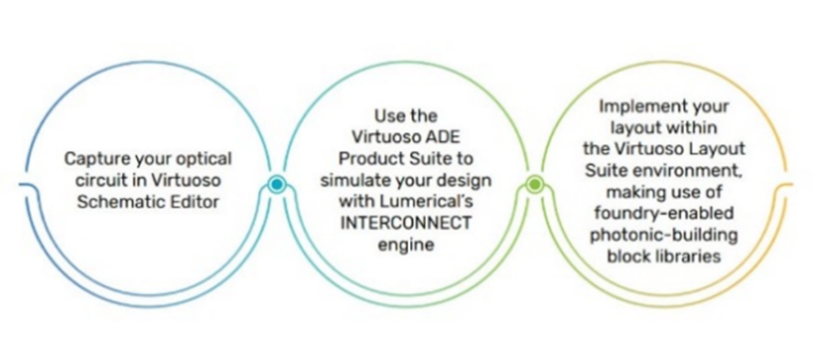

Here we are going to cover some of the basic features which will help for photonics designers.

**Observing Layout Elements**

Photonic elements are typically the result of complex mathematical calculations to generate the shapes; as such, they are usually ‘wrapped’ into a generator and controlled by a few parameters. As a matter of fact, all elements, including interconnect elements (waveguide) in the Virtuoso methodology for photonics, are expected to be instances (fixed or PCells) – this is different from the electronics methodology, where the interconnect (wires) are usually top-level shapes. This means the primary method to control any photonics elements is through its parameters, which are associated with the instances and visible interactively through the instance property form.

**Observing, creating, and understanding photonic ports**

**Related video is linked here**:

[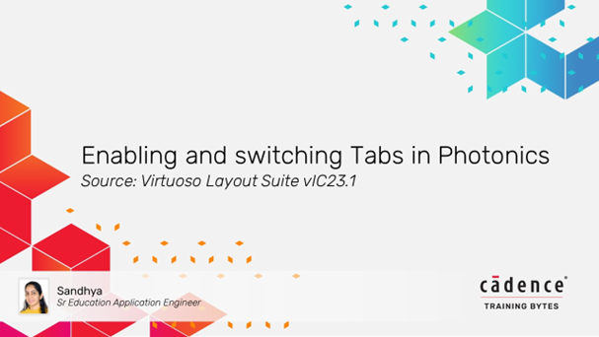](https://support.cadence.com/apex/ArticleAttachmentPortal?id=a1OPP000000IWFx2AO&pageName=ArticleContent)

**Facet definition:**

Photonic ports represent connection points between the hierarchy levels, the same as electronics pins do. However, as they need to enable the connection of waveguides, they are different in their physical role. In addition to carrying connectivity information (which they share with electrical ports), they also have optical facet information. Optical facets are defined as follows:

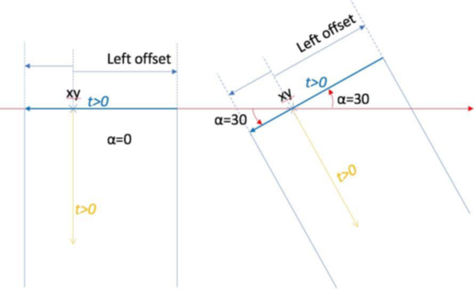

Optical facets correspond to a Virtuoso database CurvyCore object “ccFacet”. Note that non-symmetric optical facets are only supported through scripting. In addition, an optical port carries layer and curvature (bend radius) information.

**Creating Optical Ports (GUI)**

Optical ports require a layer name for creation. Temporarily reinstall the layer **Palette**to select the waveguide layers conveniently.

**Observing waveguides:**

Waveguides (optical interconnect) are instances in the system. A full section reviews specifically the different types of waveguides and their associated parameters.

To support photonic applications, auto-abutment has been significantly upgraded in comparison to electronics. Foremost, photonics abutment supports all the same features (assuming the PDK developer chooses to implement them) as electronic PDK supports. But critically, it also supports a new type of abutment based on aligning the center point of an optical port and matching facet (width, angle, layer) information. This enables any-angle abutment. Abutment is triggered by overlapping photonic ports, provided the corresponding layers are set up to trace optical connectivity in the technology database.

In addition, for photonics layout, abutment is enabled for optical pins of non-PCell devices.

Finally, abutment is also supported with optical ports, enabling the full creation of optical chains through the hierarchies.

Although some features specific to photonics were added to the layout cockpit, most of the features are in addition and complement the electrical features.

Many of the electronic features (Create Pin, Create Instance, and so on) are the same regardless of the type of elements (electronics or photonics). Photonics-specific features such as ports and connectors are available through the specialization of the existing electronic features.

Do You Have Access to the Cadence Support Portal?

If not, follow the steps below to create your account.

* *On the*[*Cadence Support*](https://registration.cadence.com/CadenceApplicationLoginScreen?appcode=cos&langcode=en)*portal, select Register Now and provide the requested information on the Registration page.*
* *You will need an email address and host ID to sign up.*
* *If you need help with registration, contact*[*support@cadence.com*](mailto:support@cadence.com)*.*

To stay up-to-date with the latest news and information about Cadence training and webinars, [subscribe](https://www5.cadence.com/ES_LP.html)to the Cadence Training emails.

If you have questions about courses, schedules, online, public, or live onsite training, reach out to us at [Cadence Training](https://www.cadence.com/en_US/home/training/contact.html).

**Become Cadence Certified**

Cadence Training Services now offers digital badges for this training course. These badges indicate proficiency in a certain technology or skill and give you a way to validate your expertise to managers and potential employers. You can highlight your expertise by adding these digital badges to your email signature or any social media platform, such as Facebook or LinkedIn. To become [Cadence Certified](https://www.cadence.com/en_US/home/training/become-cadence-certified.html?utm_source=cadence+community&utm_medium=blog&utm_campaign=cadence+certified+&utm_id=2223&utm_term=v), you can find additional information[here](https://community.cadence.com/cadence_blogs_8/b/breakfast-bytes/posts/tranining2020?utm_source=cadence+community&utm_medium=blog&utm_campaign=cadence+community&utm_id=2021&utm_term=v).

[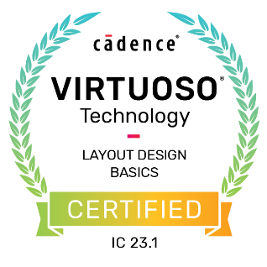](https://www.cadence.com/en_US/home/training/all-courses/84460.html) [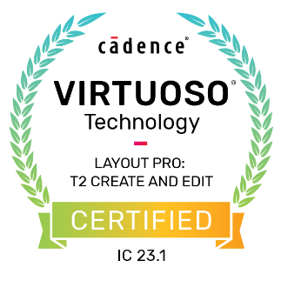](https://www.cadence.com/en_US/home/training/all-courses/85088.html?utm_source=cadence+community&utm_medium=blog&utm_campaign=virtuoso+layout+pro+t2&utm_id=1213&utm_term=v) [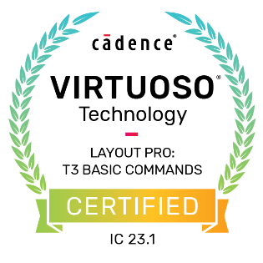](https://www.cadence.com/en_US/home/training/all-courses/85089.html?utm_source=cadence+community&utm_medium=blog&utm_campaign=virtuoso+layout+pro+t3&utm_id=1415&utm_term=v) [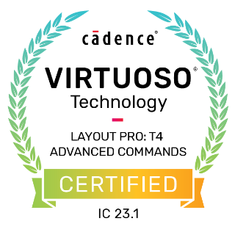](https://www.cadence.com/en_US/home/training/all-courses/85090.html?utm_source=cadence+community&utm_medium=blog&utm_campaign=virtuoso+layout+pro+t4&utm_id=1617&utm_term=v)

**Related Resources**

| **Training Bytes (Videos)** | [Generate nets and components in Photonics](https://support.cadence.com/apex/ArticleAttachmentPortal?id=a1OPP000000IW332AG&pageName=ArticleContent)  [Enabling and switching Tabs in Photonics](https://support.cadence.com/apex/ArticleAttachmentPortal?id=a1OPP000000IWFx2AO&pageName=ArticleContent)  [How to create optical port and pins](https://support.cadence.com/apex/ArticleAttachmentPortal?id=a1OPP000000IWJB2A4&pageName=ArticleContent)  [Finding and deleting unbound ports](https://support.cadence.com/apex/ArticleAttachmentPortal?id=a1OPP000000IopZ2AS&pageName=ArticleContent)  [creating instance in photonics](https://support.cadence.com/apex/ArticleAttachmentPortal?id=a1OPP000000Ioj72AC&pageName=ArticleContent)  [Abut Instances in Photonics](https://support.cadence.com/apex/ArticleAttachmentPortal?id=a1OPP000000IVzp2AG&pageName=ArticleContent) |
| --- | --- |
| **RAK** | [Virtuoso layout (EXL) for Photonics Designers](https://support.cadence.com/apex/ArticleAttachmentPortal?id=a1O3w000009l2OfEAI&pageName=ArticleContent) |
| **Online Courses** | [Virtuoso Layout Design Basics](https://www.cadence.com/en_US/home/training/all-courses/84460.html?utm_source=cadence+community&utm_medium=blog&utm_campaign=virtuoso+layout&utm_id=1011&utm_term=v)  [Virtuoso Layout Pro: T2 Create and Edit Commands](https://www.cadence.com/en_US/home/training/all-courses/85088.html?utm_source=cadence+community&utm_medium=blog&utm_campaign=virtuoso+layout+pro+t2&utm_id=1213&utm_term=v)  [Virtuoso Layout Pro: T3 Basic Commands](https://www.cadence.com/en_US/home/training/all-courses/85089.html?utm_source=cadence+community&utm_medium=blog&utm_campaign=virtuoso+layout+pro+t3&utm_id=1415&utm_term=v)  [Virtuoso Layout Pro: T4 Advanced Commands](https://www.cadence.com/en_US/home/training/all-courses/85090.html?utm_source=cadence+community&utm_medium=blog&utm_campaign=virtuoso+layout+pro+t4&utm_id=1617&utm_term=v) |

**About Knowledge Booster Training Bytes**

*Knowledge Booster Training Bytes* is an online journal that relays information about Cadence Training videos, online courses, and upcoming webinars that are available in the Learning section of the Cadence Learning and Support portal. This blog category brings you direct links to these videos, courses, and other related material, on a regular basis.

**Sandhya P Shet**

***On behalf of the Cadence Training team***

